**Designing and implementing full adder circuit on Altera board using Quartus 2**

11/2/2016

CE Lab – 4,

*Time worked on lab: 2 hours and 30 minutes.*

**Purpose:**

The purpose of this lab is to understand how full adder circuit’s work and the binary calculations that are made using it. It also goes through the working of different logic gates in the construction of the full adder circuit.

**Components used:**

Software’s: Quartus 2, ModelSim

Hardware: computer, Altera DE2 Board

**Truth Table for the full adder:**

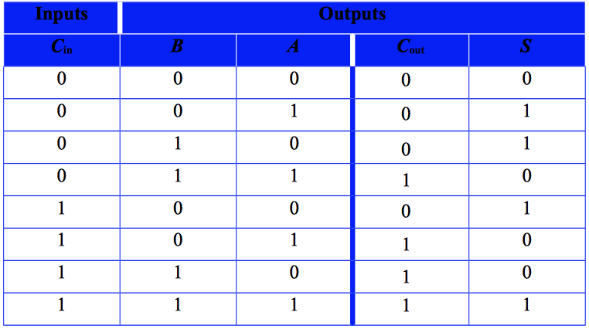

**Schematic for the Full-Adder created using Quartus II:**

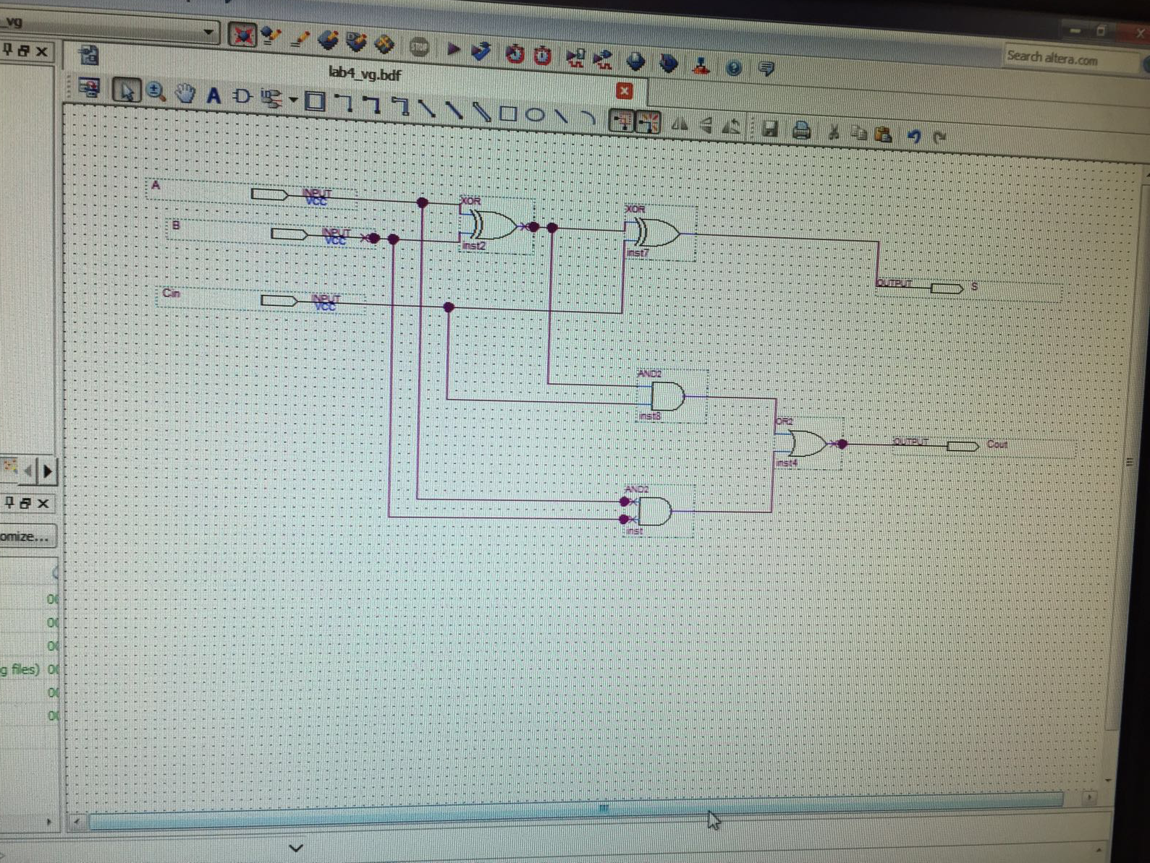

**Simulation of the full adder:**

|  |  |  |  |  |
| --- | --- | --- | --- | --- |
| **Cin** | **B** | **A** | **Cout** | **S** |
| **0** | **1** | **0** | **0** | **1** |

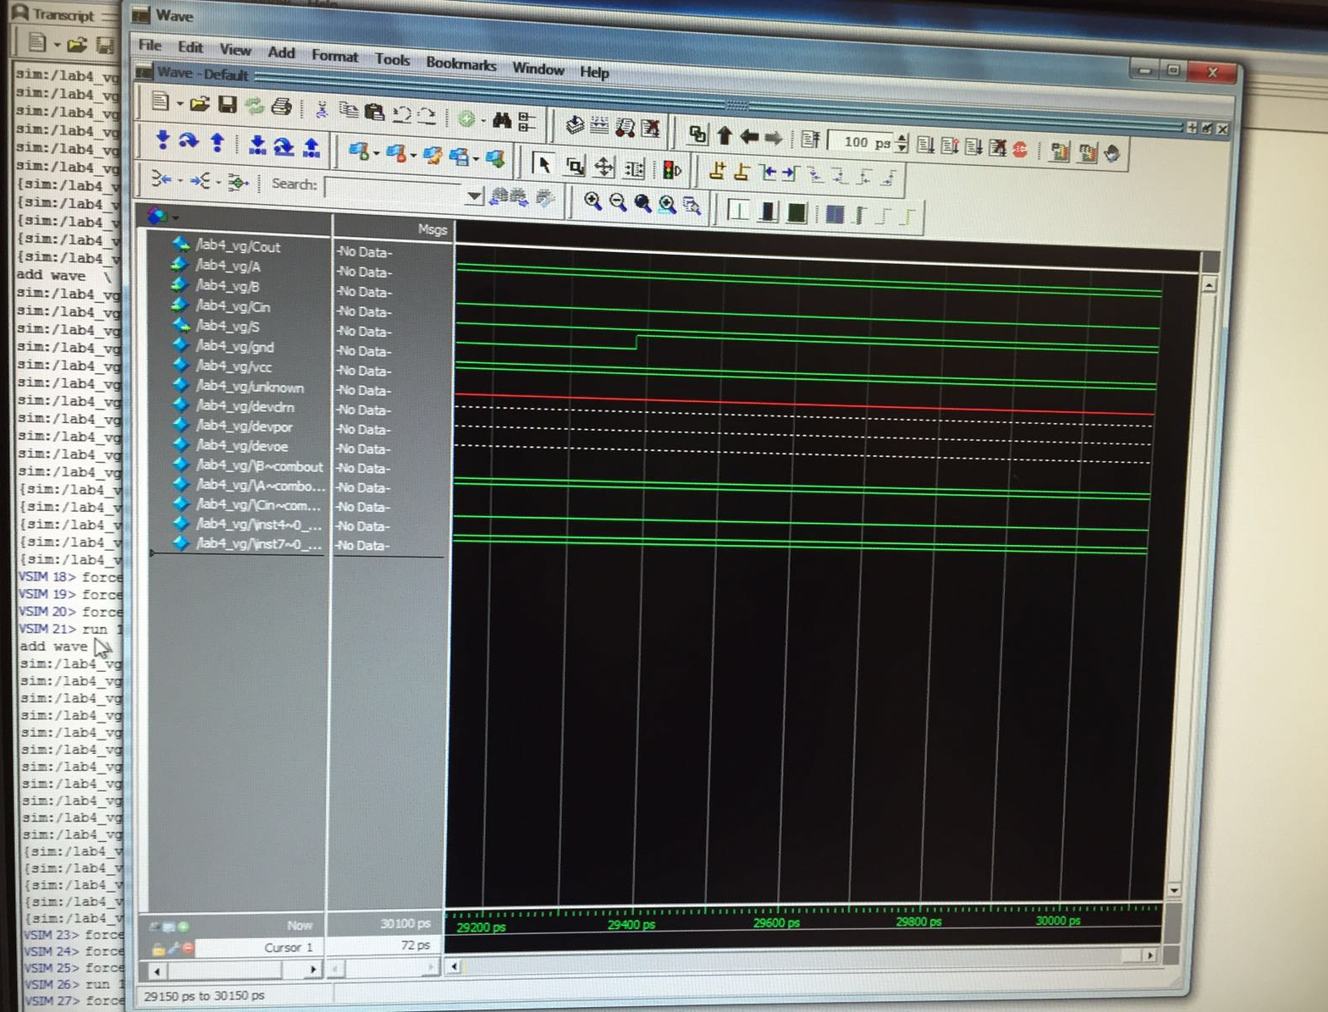

|  |  |  |  |  |
| --- | --- | --- | --- | --- |
| **Cin** | **B** | **A** | **Cout** | **S** |
| **1** | **1** | **1** | **1** | **1** |

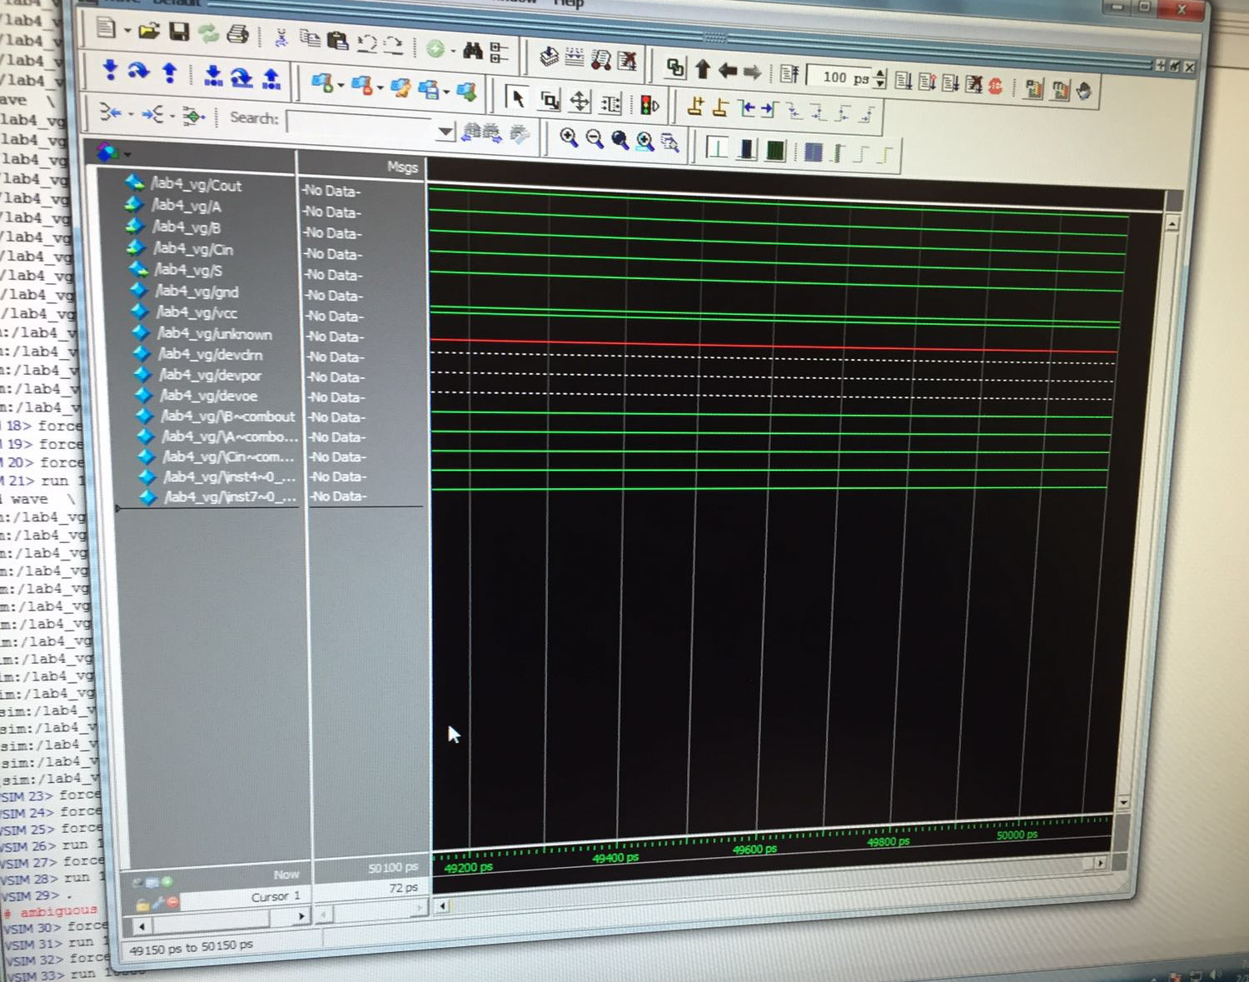

|  |  |  |  |  |
| --- | --- | --- | --- | --- |
| **Cin** | **B** | **A** | **Cout** | **S** |
| **1** | **1** | **0** | **1** | **0** |

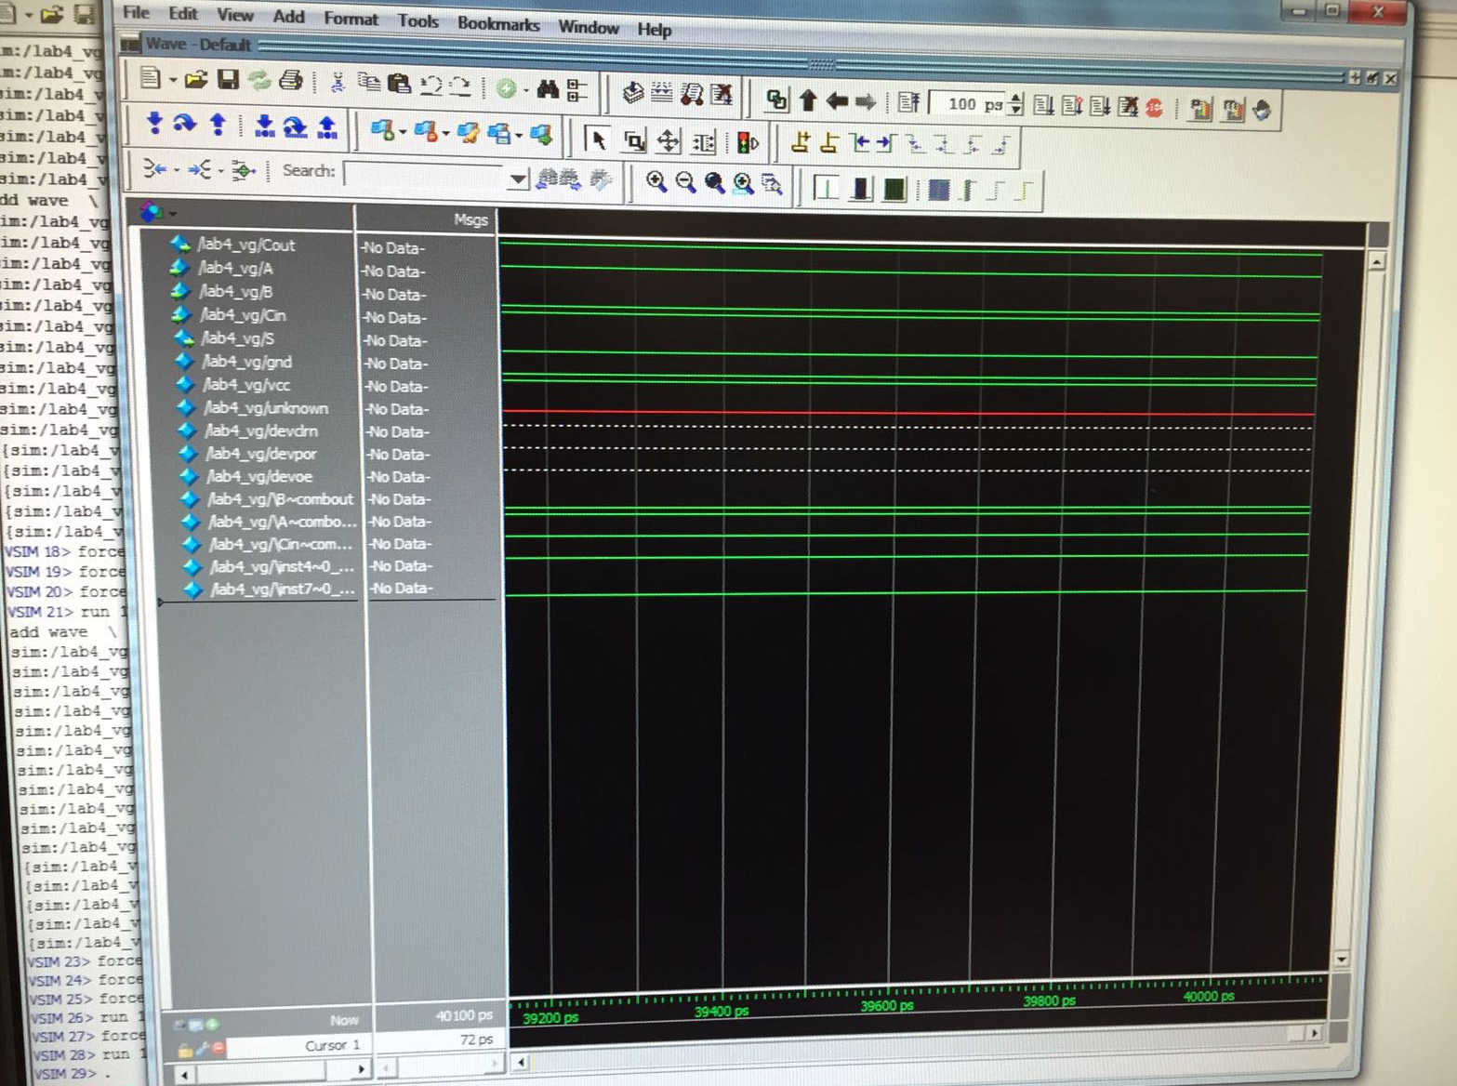

|  |  |  |  |  |
| --- | --- | --- | --- | --- |
| **Cin** | **B** | **A** | **Cout** | **S** |
| **0** | **1** | **1** | **1** | **0** |

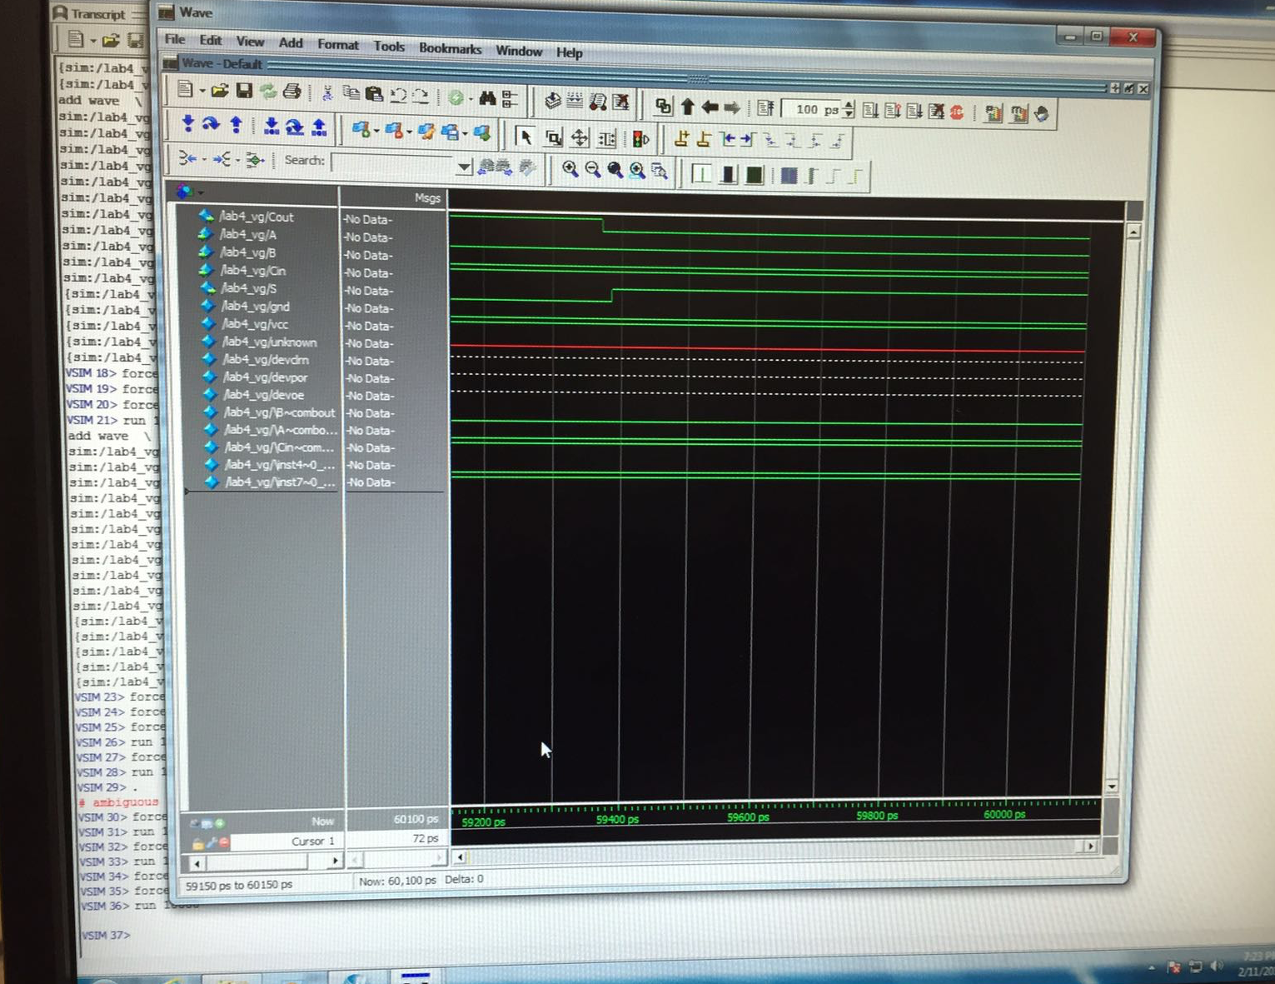

|  |  |  |  |  |
| --- | --- | --- | --- | --- |
| **Cin** | **B** | **A** | **Cout** | **S** |
| **1** | **0** | **1** | **1** | **0** |

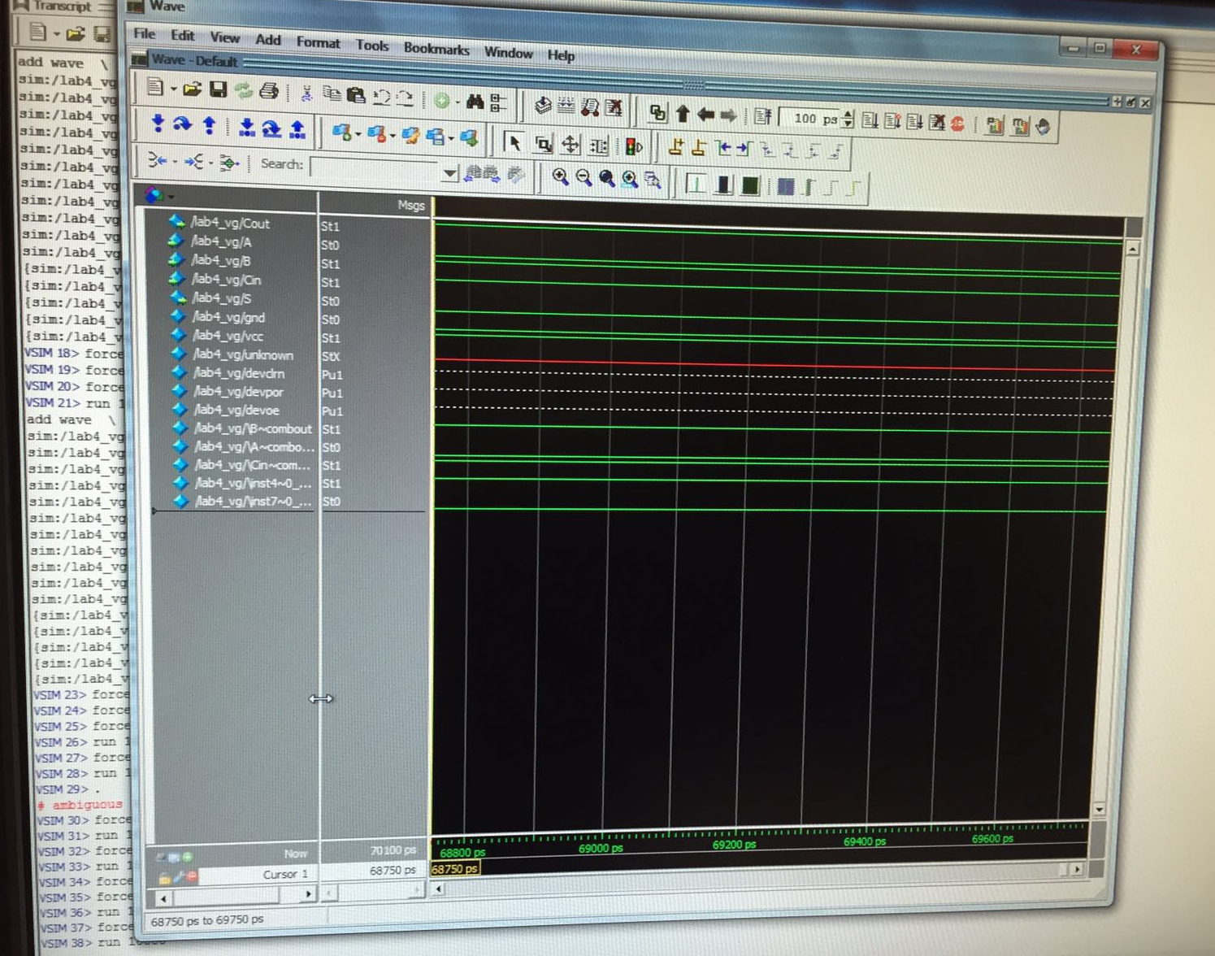

|  |  |  |  |  |
| --- | --- | --- | --- | --- |
| **Cin** | **B** | **A** | **Cout** | **S** |
| **0** | **0** | **1** | **0** | **1** |

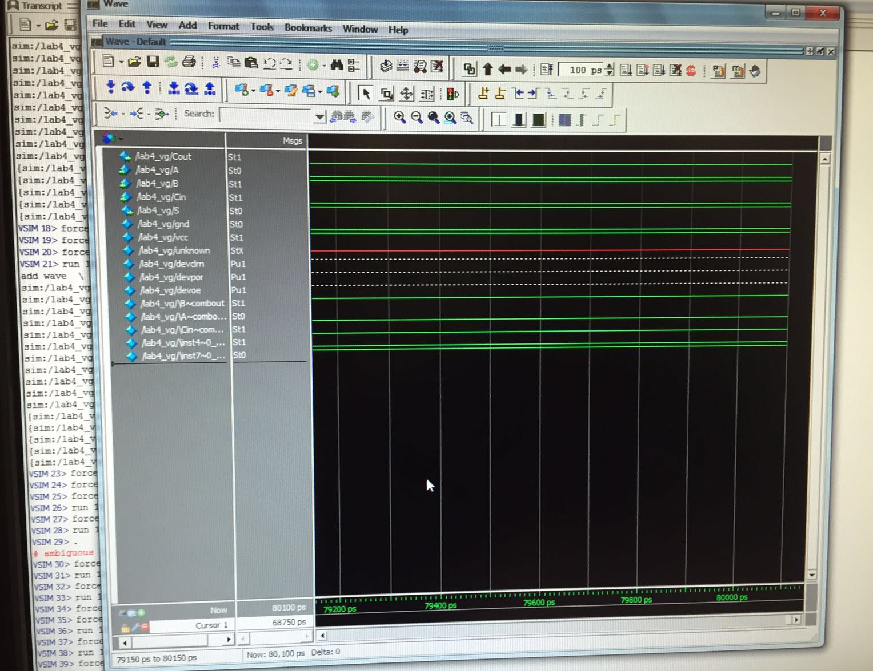

|  |  |  |  |  |
| --- | --- | --- | --- | --- |
| **Cin** | **B** | **A** | **Cout** | **S** |
| **0** | **0** | **0** | **0** | **0** |

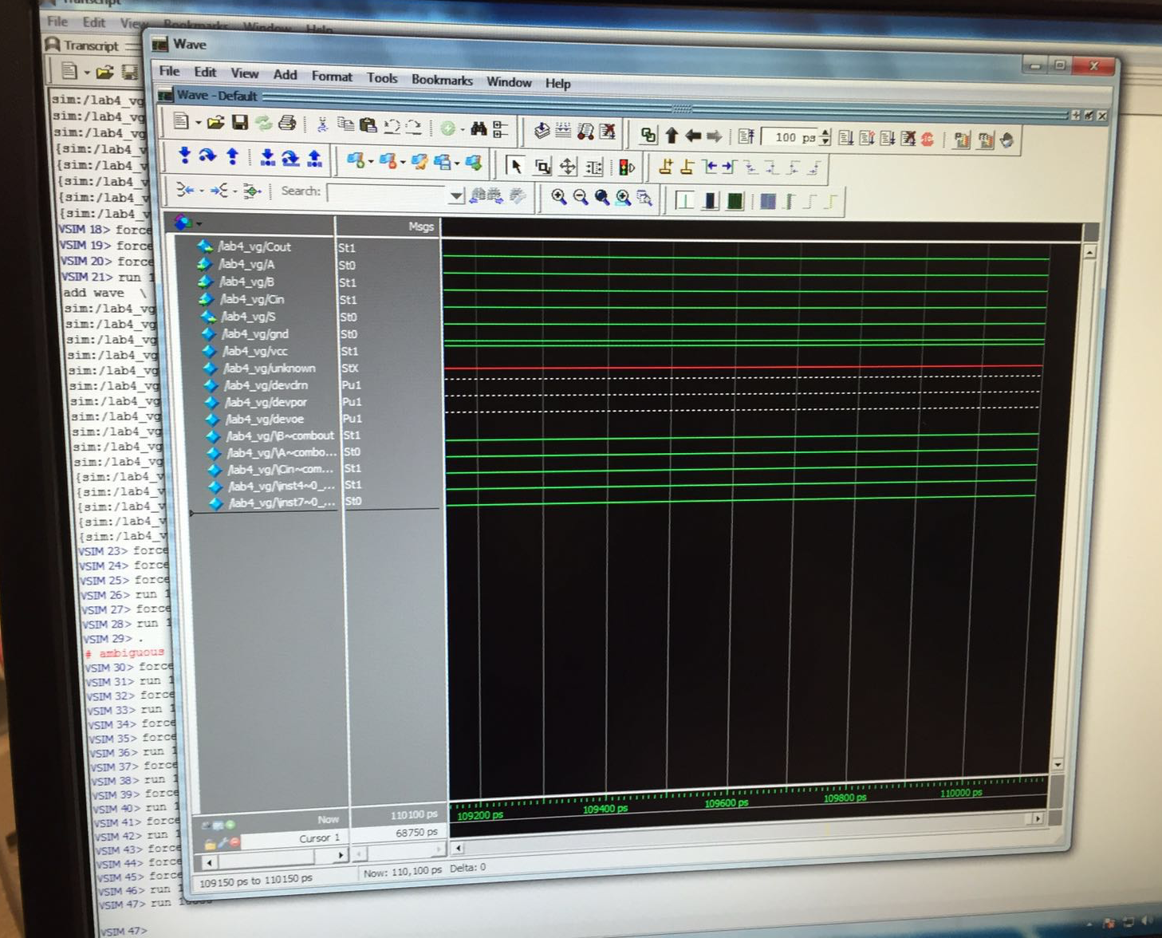

|  |  |  |  |  |
| --- | --- | --- | --- | --- |
| **Cin** | **B** | **A** | **Cout** | **S** |
| **1** | **0** | **0** | **0** | **1** |

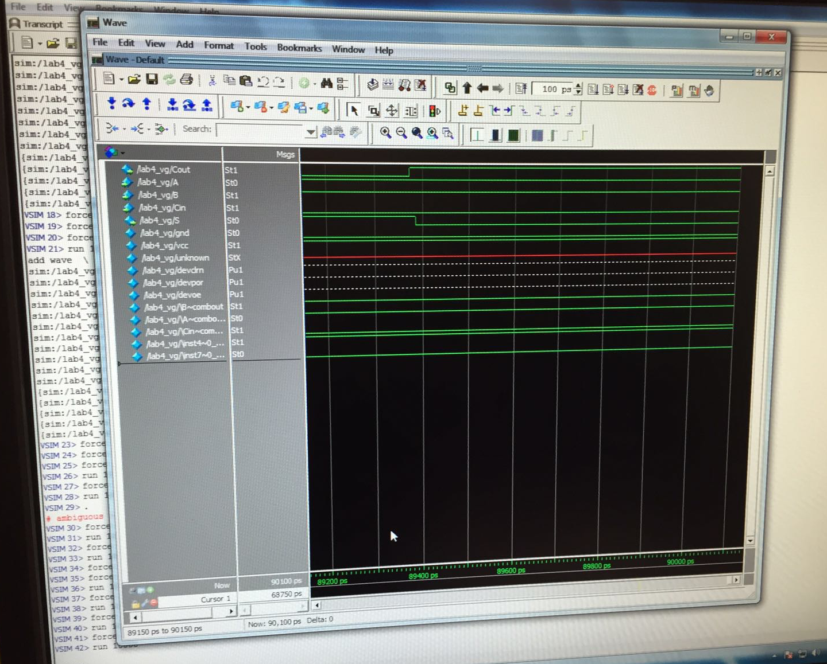

**Simulation on the board:**

